1. **Logo**

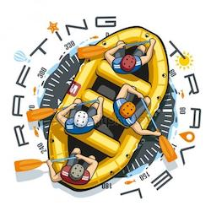

1. **Colors**

* **Primary color:** CBFF8C ; Mindaro
* **Secondary color:** E3E36A ; Straw
* **Accent1 color**: FEF9FF ; White Ghost
* **Accent2 color:** 413C58 ; English Violet

1. **Typography**

**Heading font;** Rock salt

**Text font**; Roboto Condensed

1. **URL**

[**https://coolors.co/cbff8c-e3e36a-fef9ff-413c58-2a324b**](https://coolors.co/cbff8c-e3e36a-fef9ff-413c58-2a324b)